Smart Temperature Transmitter Module

Manual

- Overview
Temperature Transmitter Module H248 is designed in conformity with HART protocol. It can be monitored and configured by HART communication devices.

The manual includes the technical specifications of H248 and configuration debugging methods on H248 smart temperature transmitters to use of H248 configuration software.

Please read the manual before using H248.And follow the instructions as the manual. If you have any further problems, please do not hesitate to contact us, and it will be a great pleasure for us to help you. Thanks for your order.

- Main Features of Smart Transmitter Module
  - Interface Features & Technical Specification
- Remote management via HART Communicator or PC
- Output Signal: 4~20mA with HART protocol（two wires）
- Communication in conformity with HART protocol
- No interference to 4~20mA analog output
- Power Supply: 12V～36V DC
- Isolation (500V AC ) between input and output
- A/D Digital Accuracy: ±0.1℃ for RTD;±0.2℃ for E; 0.25℃ for J; ±0.25℃ for K; ±0.40℃ for N; ±0.60℃ for R; ±0.25℃ for T; ±0.5℃ for S; ±0.75℃ for B
- D/A Output Accuracy: ±0.05% F.S

- General Analog Accuracy= A/D Digital Accuracy+ D/A Output Accuracy
（If it's the thermocouple input, it needs add an accessional error of ±0.25℃ caused by cold terminal temperature compensation.）
- Damping: 0～32s adjustable
- Operation Temperature: -40℃～+85℃

  - Signal Description and Interface Definition
    - HART Communication Output Wave
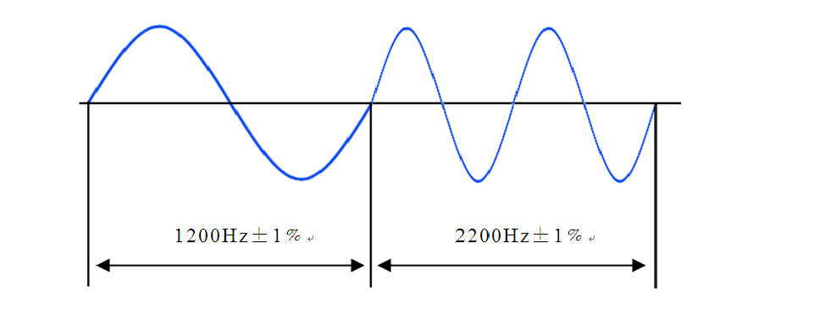
Figure 2-1 HART Communication Output Wave

    - connecting terminal Definition
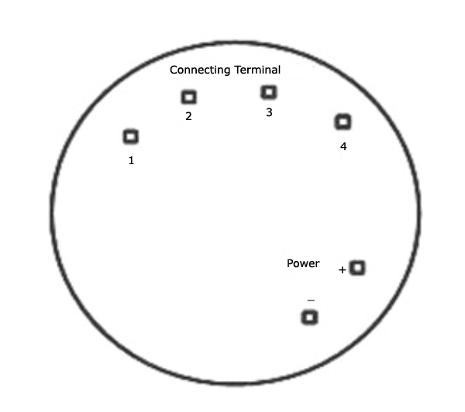
Figure 2-2 Temperature Transmitter Module wire connecting terminal
Note: “+” is positive electrode and “-” is negative electrode of external power;
1, 2, 3, 4 should be connected to the sensor.
When apply thermocouple or thermal resistor as sensor, the special interface definition is shown as below (See Figure 2-3):
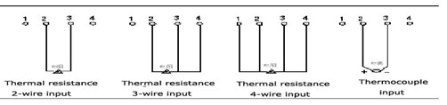
Figure 2-3 Sensor Wiring Diagram

Note: When apply thermocouple as sensor, pin 2 for positive and pin 3 for negative.

  - Internal Block Diagram
Internal function Block Diagram of Temperature Transmitter Module(see Figure 2-4)

CPU

Isolation
Signal Conversion
VCC

VCC
Sensor
Interface
Input

Current Output

HART
Figure 2-4 Internal Block Diagram of Temperature Transmitter Module

  - Connection between transmitters and Computer

Connection between transmitters and computer (see Figure 2-5)
HART
+ 4-20mA
HK-HART232
HART Signal
RS232 Interface
250
Ohms
+24V Power

Figure 2-5 Connection between Temperature Transmitter and Computer

- Operation via configuration Software of H248
H248 Module can communicate with PC via configuration /debug device (HK-HART 232), to achieve more functions, such as information management, configuration, variable monitoring, calibration and maintenance etc.

  - Instrument information

Attribute
This function allows you to read instrument manufacturer, product model, generic version number, dedicated version number and software version number.

Sensor Information
This function allows you to read the serial number of the sensor, unit, upper/ lower limit of the sensor and minimum range of PV.

Range
This function allows you to read unit, upper/ lower limit of the transmitter, damping and transfer function of PV.

Setting
This function allows you to set station number of instrument, polling address, assembly code, sensor serial number and product number, the range of polling address is 0 ~15. The instrument in a multi-mode when the polling address is not at 0, at this moment, the output current of the instrument is fixed at 4 mA

Information
The function allow you to set management information, such as, installation date, descriptive information, etc

  - Instrument Configuration
This function allows you to make configuration of parameters of the instrument, such as PV unit, upper limit and lower limit of PV, damping, and dynamic variables of instrument display.

Unit of Range:
Optional units: ℃, ℉, R, K, mV, Ω.

Upper Limit and Lower Limit of Range:
Setup the measuring upper limit and lower limit of instruments. When the instrument is under single-drop mode（polling ID is 0）, the lower limit output 4mA, and the upper limit output 20mA.

Damping:
The damping value can be adjusted between 0 to 32 seconds. When the damping value increases, the stability of the instrument output will also improve, while the response time will be prolonged.

  - Instrument Trim
Before calibrating electric current, connect a 5.5 bit (at least) ammeter in series, or connect a 250Ω (500Ω) and 0.05% accuracy resistance in series to monitor the value of the voltage across more than 4.4 bit (at least) voltmeter to indirectly calculate the value of the current of the transmitter output.

Calibration current can calibrate the analog output of the instrument. When there is large deviation between actual output current value and displays current value of the instrument, you should calibrate it. When to Calibrate the current, 4mA (zero) and 20mA (full scale) should be calibrated respectively. To set up the polling address to "0" (When the polling address is not "0", the transmitter is in the multi-mode, it is not allowed for calibration of the loop current).

Click "enter calibration” to calibrate output current. Presently, “Send Calibration” and “exit calibration” buttons become active, indicating that the output current can be calibrated. To select required calibration value of the current in the theoretical output value, and then, to input the measured transmitter output current in the adjustment value dialog, and click "Send calibration" begin to calibrate the output current. After finish the calibration, click the "exit calibration" to end the current calibration operation.

3.4 Monitoring variables
This function enables you to monitor the dynamic variables of instrument, such as current value, PV, and PV % and channel acquisition value. If apply thermocouple as sensor, you could monitor resistance value.

3.5 User Calibration
In order to further improve the accuracy of the instrument, you could do the 5-point user calibration after manufacturer calibration. There are two ways to calibrate, one is by temperature, another is by resistance value when the sensor is the thermal resistance or voltage value when the sensor is a thermocouple and the instrument can save the two types of calibration data. To perform user calibration，monotonic increase in the sensor input must be guaranteed and you should wait for enough time at each calibration point so that the measured values ​​are stable.

In the course of using, if not select, the type of the default user calibration is the last calibration mode, also, the drop-down menu will display the instrument that has been calibrated and successfully downloaded. Meanwhile, by clicking the "Clear" button, you could cancel the use of user calibration at any time. The cancellation is unrecoverable. You might re-calibrate when necessary.

Special attention, when reset the instrument type, sensor type, or connection mode, the data of the user calibration will be automatically cleared, and cannot be restored, you may redo the calibration if necessary.

3.6 Advanced Functions

Transmitter Configuration

Instrument type: thermometer, voltmeter or ohmmeter.

Sensor type: When thermometer, sensor type could be thermal resistance or thermocouple. When choose thermal resistance, optional types include Pt50, PT100, Cu50, Cu100, and PT1000, if choose thermocouple, optional types include R, S, B, J, T, E, K, N.
For thermal resistance, you need set the connection mode and line resistance compensation:

Connection mode: two-wire, three-wire or four-wire input mode.

Wire-resistance Compensation: With two-wire, you could set the lead resistance value (refers to the resistance value of single lead) in order to improve the accuracy of the instrument. As the resistance value that the instrument collects is the sum of the sensor resistance, lead resistance as well as contact resistance, so we could subtract double value of the lead resistance from the total collection value, in order to get more accurate data.
When it is ohmmeter, you could set connection mode and wire-resistance compensation.

Connection mode: two-wire, three-wire or four-wire input mode.

3.7 Additional functions

EEPROM backup and restore: click “EEPROM data backup”, instrument information, instrument configuration, calibration data, transmitter configuration information is saved in a sole storage area of instrument EEPROM; Click “the EEPROM data recovery " the backup data in a sole storage area of the EEPROM will replace all data being displayed.

Instrument data PC backup and restore: do redundant backup for instrument calibration data. Click "save", data of the manufacturer calibration, user calibration and excitation current calibration will be saved into your PC in text file format, and click “read”, those data will appear from your PC when the instrument EEPROM is failure or accidental loss of those data.
Obtain information: to obtain the final-output dynamic information of the instrument.
H248 Smart Temperature Transmitter Module

Manual

Content
H248 1
Manual 1
1. Overview 1
2. Main Features of Smart Transmitter Module 1
2.1 Interface Features & Technical Specification 1
2.2 Signal Description and Interface Definition 1
2.3 Internal Block Diagram 3
2.4 Connection between transmitters and Computer 3
3. Operation via configuration Software of H248 3
3.1 Instrument information 4
3.2 Instrument Configuration 4
3.3 Instrument Trim 5
3.4 Monitoring variables 5
3.5 User Calibration 5
3.6 Advanced Functions 6
3.7 Additional functions 6

